PROGRAMMING IN JAVA
CO1 – ASSIGNMENT 1
DESIGN, IMPLEMENT AND VALIDATE AN OBJECT-ORIENTED MODEL
FOR A CAMPUS SMART-PARKING SYSTEM

Submitted by: Gonugunta Ajay Kumar
Register Number: 192372300
Course: Programming in Java
Course Outcome: CO1 – Java Fundamentals and Object-Oriented Programming
GitHub Repository: https://github.com/G-ajay-kumar-1/CSA0918---Java

Abstract
This assignment designs and implements an object-oriented model for a multi-floor campus smart-parking facility. The system allocates suitable free slots, issues unique tickets, records vehicle entry times, calculates parking fees and releases slots when vehicles exit. The design applies Java data types, arrays, classes, constructors, static members, inheritance, method overriding, polymorphism, abstract classes, interfaces, packages and encapsulation. It also evaluates alternative representations and algorithms using Big-O notation. The Day-4 design challenge extends the model to e-bikes, delivery vans, visitor one-day passes and unequal slot counts across five floors.

Contents
- 1. Problem overview and assumptions
- 2. Task 1 – Problem analysis and objects
- 3. Task 2 – Data representation
- 4. Task 3 – Control logic and pseudocode
- 5. Task 4 – Classes, objects and constructors
- 6. Task 5 – Static members and object life cycle
- 7. Task 6 – Inheritance hierarchy
- 8. Task 7 – Method overriding
- 9. Task 8 – Polymorphism
- 10. Task 9 – Abstraction
- 11. Task 10 – Packages and encapsulation
- 12. Task 11 – Implementation, testing and defence
- 13. Task 12 – Day-4 design challenge
- 14. Conclusion
- 15. References and evidence checklist

1. Problem overview and assumptions
The campus parking facility contains multiple floors, each with a fixed number of numbered slots. It serves two-wheelers, cars and electric vehicles. An electric vehicle may use a charging slot, for which a separate charging fee applies. When a vehicle enters, the system finds a suitable free slot, creates a unique ticket and records the entry time. At exit, the slot is released and the fee is calculated. Eligible students and staff with a valid monthly pass receive free parking; visitors pay the applicable fee.

Assumptions used in the sample implementation
- Each registration number identifies at most one active parking session.
- The first started hour is charged in full in the baseline fee examples; 0 minutes produces 0 parking fee.
- Illustrative baseline rates are Rs 10/hour for a two-wheeler and Rs 30/hour for a car. The EV charging rate is Rs 12/kWh, matching the provided FeeDemo specification.
- A valid monthly pass makes student/staff parking free; visitors are not eligible for that monthly-pass exemption.
- The Day-4 handout does not specify the e-bike flat fee or one-day-pass price. The sample uses an e-bike parking fee of Rs 20 per visit and treats a valid visitor one-day pass as waiving the parking fee. These are assumptions, not values supplied by the handout.
- The sample delivery-van implementation applies double the car hourly rate during 09:00–17:00 and normal car rate outside that window; it prorates partial hours. Confirm the rounding rule and rates with faculty.

Task 1 – Understand the problem and identify the objects
Problem inputs: vehicle registration/type, user category/pass validity, entry and exit times, and slot configuration. Outputs: slot allocation, unique ticket, parking fee, occupancy and validation messages. Candidate classes: Vehicle (identity and fee behaviour), ParkingSlot (position and occupancy), ParkingFacility (allocation/release), ParkingTicket (entry record), User/Pass (eligibility), and ParkingService (use-case coordination). Rules: one vehicle per slot; no duplicate active registration; ticket IDs are unique; invalid positions are rejected; released slots become reusable. Assumptions must be stated, especially rates and billing boundaries. Objects keep related state together. Parallel arrays require matching indexes and synchronized updates. Searching registration is O(n) in either a simple object array or parallel arrays; adding an attribute to parallel arrays requires another array and synchronized maintenance, while an object model adds a field/accessor to Vehicle. Space is O(n) references plus object overhead for objects; parallel arrays store separate arrays and primitive/reference values.

Candidate classes and responsibilities
- Vehicle: stores registration identity and exposes vehicle-specific fee behaviour.
- ParkingSlot: stores floor/slot position and the current vehicle, if occupied.
- ParkingFacility: owns the floor/slot structure and performs allocation and release.
- ParkingTicket: stores unique ticket ID, vehicle, slot, entry time and pass information.
- Pass: represents eligibility rules for discounted or free parking.
- ParkingService: coordinates entry, ticket creation, exit, fee calculation and validation.

Business invariants
- A slot cannot contain more than one vehicle.
- An active registration number cannot be duplicated.
- Ticket identifiers must not be reused during the process lifetime.
- A slot can be released only if its floor and slot indexes are valid and it is occupied.
- A fee cannot be negative; invalid duration and energy values are rejected.
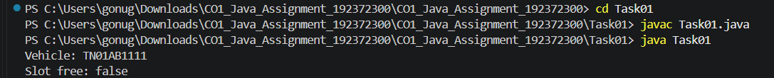

Task 2 – Choose the data representation
Use int for floor/slot/count/minutes, String for registration, LocalDateTime for timestamps, long for elapsed minutes, and double or BigDecimal for currency (BigDecimal is preferable in a production billing system). A jagged String[][] represents floors with different slot counts. Use Scanner for console input. Integer division 95/60 gives 1, which undercharges if every started hour is billed; ceiling division for non-negative minutes is (minutes+59)/60. Jagged arrays use O(total slots) space and slot lookup by known indexes is O(1). A flattened one-dimensional array needs a prefix-offset mapping when floors differ in size; a fixed slotsPerFloor formula is invalid for unequal floors. ArrayList<String[]> retains per-floor sizing with dynamic outer-list growth.
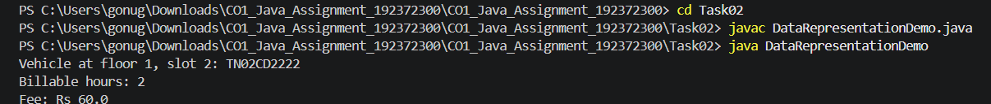

Task 3 – Design the control logic
Allocation pseudocode: FOR each floor; FOR each slot; IF slot is empty, store registration and RETURN floor/slot; END loops; RETURN no-space. Release pseudocode: validate floor; validate slot against that floor; if empty return false; otherwise set null and return true. Fee pseudocode: validate duration; compute billable hours with ceiling division; choose rate/slab; apply eligible pass; return fee. The provided ParkingFacility program is completed and its expected output is the sequence [0,0], [0,1], [1,0], null, true false false, [0,1]. Scan allocation is O(T) worst case where T is total slots; release is O(1). A stack/list of free positions can make allocation/release amortized O(1), with O(T) extra storage for free-position records and care needed to prevent duplicate stack entries.

Pseudocode – allocate a slot
PROCEDURE ALLOCATE(vehicleNo)
FOR each floor f
FOR each slot s on floor f
IF slot[f][s] is empty THEN
slot[f][s] <- vehicleNo
RETURN (f, s)
END IF
END FOR
END FOR
RETURN NO_FREE_SLOT
END PROCEDURE

Pseudocode – calculate parking fee
PROCEDURE CALCULATE_FEE(minutes, hourlyRate, passStatus)
IF minutes < 0 THEN
REJECT input
END IF
IF minutes = 0 THEN
hours <- 0
ELSE
hours <- (minutes + 59) DIV 60
END IF
fee <- hours * hourlyRate
IF eligible monthly pass is valid THEN
fee <- 0
END IF
RETURN fee
END PROCEDURE
The executable implementation for the required Complete the Code exercise is Task03/ParkingFacility.java. It preserves the provided main() method and implements allocation and release.
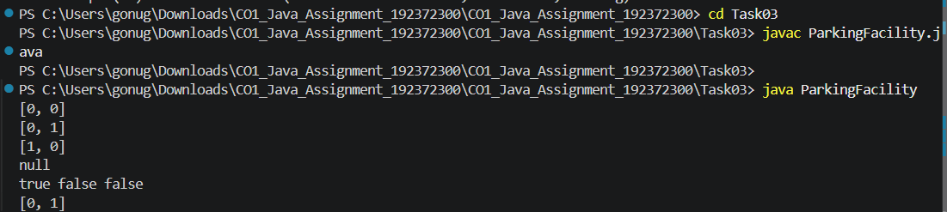

Task 4 – Design classes, objects and constructors
ParkingTicket uses a parameterized constructor to establish required state, a no-argument constructor can delegate using this(...), and a copy constructor should copy ticket data only if a new unique ticket ID is issued. Constructor chaining avoids duplicate validation. Factory methods can name creation intent and validate before returning. Setter-based construction may temporarily expose an invalid object. Creating n objects is O(n) total time and O(n) object storage for all approaches; the principal difference is validation safety and maintainability, not asymptotic complexity.

Task 5 – Apply static members and the object life cycle
The ticket sequence is class-wide and therefore static. Per-ticket entry time and registration remain instance fields. Static methods can expose the current ticket sequence or validate class-wide configuration; a static initializer is appropriate only for fixed shared setup. After exit, a ticket is eligible for garbage collection only when no reachable reference points to it. With one static counter, storage is O(1) regardless of k facilities and n tickets. An instance counter uses O(k) counters for k facilities and can generate duplicate IDs across facilities unless facility identity is included in the ticket key.
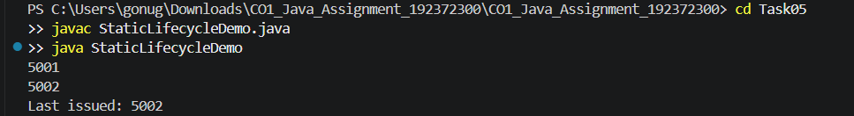

Task 6 – Design the inheritance hierarchy
Vehicle is the superclass; TwoWheeler and Car are subclasses; ElectricCar extends Car and implements Chargeable. This demonstrates hierarchical and multilevel inheritance. Subclasses inherit registration identity and add specialized rate/capability. super(...) invokes the parent constructor first. Constructor trace: Vehicle -> Car -> ElectricCar. UML: Vehicle (abstract) <|-- TwoWheeler; Vehicle <|-- Car; Car <|-- ElectricCar; ElectricCar ..|> Chargeable. Composition alternative: Vehicle has a VehicleType/PricingStrategy object. Adding a new type can be done by adding a strategy rather than subclassing. Fee lookup is O(1) in either approach; per-object space includes one strategy reference in composition, while inheritance uses the runtime class identity and object header. Composition is more flexible when pricing changes independently of vehicle identity.

UML class relationship (text form)
Vehicle (abstract)\n / \\\n TwoWheeler Car\n |\n ElectricCar - - - implements - - -> Chargeable
Constructor execution for ElectricCar: Vehicle constructor executes first, then Car constructor, then ElectricCar constructor. This order occurs because each subclass constructor invokes its superclass constructor using super(...).
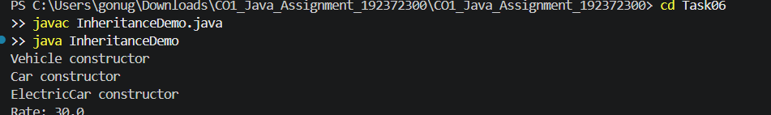

Task 7 – Override and specialise behaviour
Each concrete vehicle overrides ratePerHour(); Vehicle's calculateFee calls it polymorphically. @Override lets the compiler detect signature mistakes. An override must preserve a compatible signature/return type and cannot reduce access. final can protect registration identity or methods whose rules must not change. equals and hashCode must use the same identity rule; registration number is used here. If a switch on type is used, each added type requires editing the central switch and tests; switch lookup is O(k) in a simple sequential design or O(1) for a well-formed enum switch, but it creates central coupling.
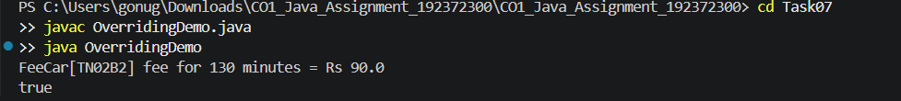

Task 8 – Apply polymorphism
Overloading is compile-time polymorphism, e.g. calculateFee(int minutes) and calculateFee(LocalDateTime in, LocalDateTime out). Runtime polymorphism occurs when Vehicle v refers to an ElectricCar and v.calculateFee(...) invokes the most specific override. The declared reference type controls accessible methods; the actual object type selects overridden implementation. FeeDemo output expected by the assignment: TwoWheeler TN01A1 -> Rs 30.0; Car TN02B2 -> Rs 90.0; ElectricCar TN03C3 -> Rs 210.0; true. The last true follows because equals compares registration only; this is a design choice and may be too broad if vehicle category must be part of identity. Dynamic dispatch is effectively O(1); repeated instanceof branches can require up to k checks and make extensions harder.

Dynamic dispatch trace
- Declared reference type: Vehicle.
- Actual object type: ElectricCar.
- Call: v.calculateFee(130).
- The inherited calculation method invokes the overridden ratePerHour() implementation; the ElectricCar object is treated as a Car for the parking rate in this example.
- The Chargeable interface check then adds 10 kWh × Rs 12 = Rs 120 charging fee.
The provided FeeDemo prints true for new Car("TN02B2").equals(new ElectricCar("TN02B2")) because equals() compares only registration numbers. This may be unsuitable if vehicle category is part of business identity; the system should explicitly choose and document its identity rule.
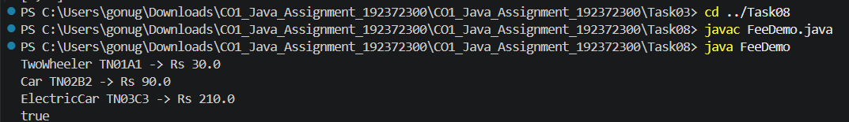

Task 9 – Introduce abstraction
Vehicle is abstract because a generic vehicle has shared identity but no single universal rate. Chargeable is an interface because charging is a capability that only some vehicles support. A class can implement multiple interfaces. Interface default methods provide shared optional behaviour; static interface methods hold related utility functions. Reversing the roles would make it harder for Vehicle to hold shared instance state and constructors because interfaces have no ordinary instance constructors or per-object instance fields. Java class inheritance is single; interfaces support multiple type inheritance. Method dispatch time is generally O(1); per-object fields are determined by the concrete class.
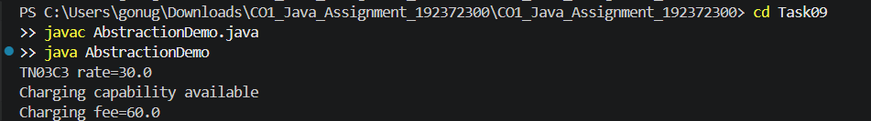

Task 10 – Enforce encapsulation through packages and access modifiers
Suggested packages: parking.model for Vehicle, ParkingSlot and ParkingTicket; parking.service for allocation, billing and validation; parking.app for the entry point. Fields are private; constructors and public service methods are public; protected is reserved for subclass hooks; package-private is suitable for internal helpers. Setters validate non-negative durations and valid slot positions. Wrapper types support collections and nullable values, but Integer objects should be compared with equals rather than == because == may compare references. Encapsulation centralizes validation; validation per update is O(1), whereas public fields force repeated checks at every caller and increase defect risk.

Suggested package structure
parking/\n model/ Vehicle.java, ParkingSlot.java, ParkingTicket.java\n service/ ParkingService.java, FeeCalculator.java\n app/ ParkingApplication.java

Task 11 – Implement, test and defend the design
The integrated program uses a jagged array for slots and a HashMap keyed by registration number for active tickets. Normal tests include different vehicle types, exits and monthly-pass users. Boundary tests should include zero minutes, 60 minutes, 61 minutes, the last free slot and full capacity. Invalid tests should include duplicate registration, unknown/missing ticket and invalid slot. For a hand calculation with 65-minute visitor two-wheeler parking: ceil(65/60)=2 hours; at Rs 10/hour the fee is Rs 20. For a 120-minute student car with valid monthly pass, fee is Rs 0. HashMap lookup is average O(1), worst-case O(n); array lookup is O(n); ArrayList lookup is O(n). All store O(n) active tickets, with map/list metadata overhead. Record actual output screenshots after running locally.

Test plan – complete actual results after local execution
Test | Input / scenario | Expected result | Actual result (fill after run)
T11-01 | Visitor two-wheeler, 65 minutes, Rs 10/hour | Rs 20 | ________________
T11-02 | Student car with valid monthly pass, 120 minutes | Rs 0 | ________________
T11-03 | Zero-minute parking | Rs 0 | ________________
T11-04 | Car parking exactly 60 minutes | Rs 30 | ________________
T11-05 | Car parking 61 minutes | Rs 60 | ________________
T11-06 | Duplicate active registration | Reject with validation error | ________________
T11-07 | Exit with unknown registration | Reject with validation error | ________________
T11-08 | Facility full | No slot / null allocation | ________________
Manual collection example: a visitor two-wheeler parked for 65 minutes is billed for ceil(65/60)=2 hours. At Rs 10 per hour, the expected amount is Rs 20. A student car with a valid monthly pass is charged Rs 0 under the stated rule. Use the actual program run to confirm the recorded result.
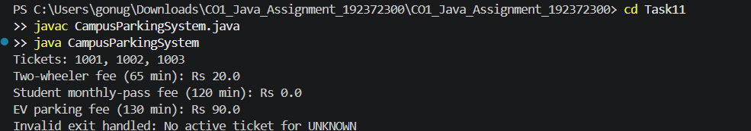

Task 12 – Re-evaluate and adapt the design
Changed requirements: e-bikes have a flat fee, delivery vans are charged at double the car rate during 09:00–17:00, visitors may buy a one-day pass, and the facility grows to five unequal floors. The jagged array already supports unequal floor sizes. A PricingRule abstraction or overridden fee method keeps rates out of allocation logic. OneDayPass implements Pass and is valid only for a visitor on its purchased date. The sample implementation assumes e-bike flat fee Rs 20 and car rate Rs 30/hour because the assignment does not specify amounts; confirm or replace these assumptions with faculty-approved rates. Delivery van billing in the sample is prorated by time segments; if faculty expects each started hour to be rounded up, adjust and document that rule. Defend the design by reporting how many existing classes changed, tests for new categories, extension effort and trade-offs.

Impact analysis
- New vehicle categories require new fee behaviour.
- Delivery van pricing introduces a time-window rule.
- Visitor one-day pass introduces a date-based eligibility rule.
- Five floors with unequal slot counts require a jagged array or another variable-length floor representation.

Design decision
Modify and extend the original design. Keep the jagged array and slot allocation service because they already support unequal floor sizes. Add ElectricBike and DeliveryVan subclasses, a Pass interface and OneDayPass implementation. Keep pricing behaviour in vehicle/pricing abstractions rather than mixing category checks into the slot-allocation algorithm.
The code in Task12/ExtendedCampusParkingSystem.java is a working sample of the extension. The e-bike amount and one-day-pass fee treatment are assumptions because the assignment handout does not define exact values. These assumptions must be approved or adjusted before submission.

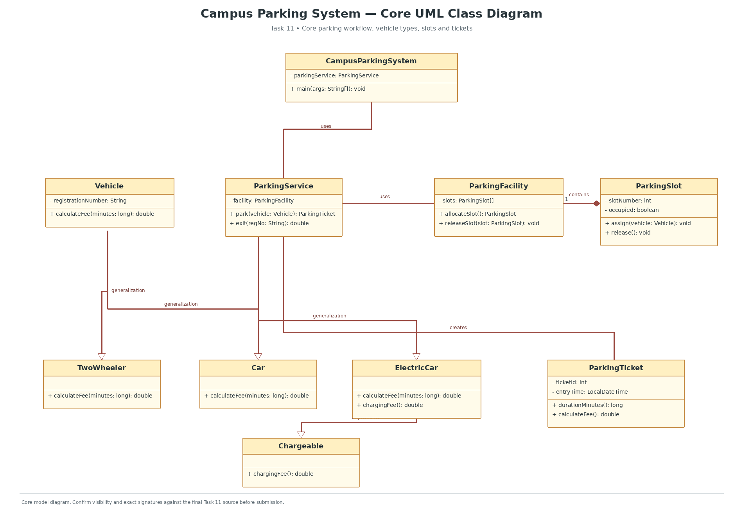

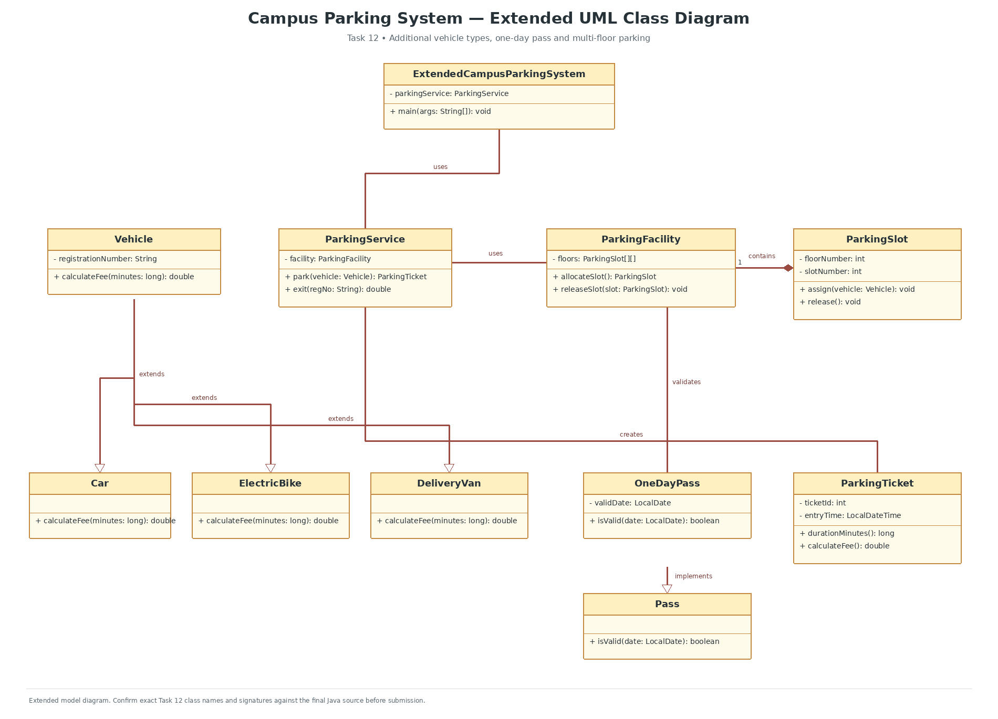

Evidence-based defence to complete
- Record the exact number of original classes changed after implementing the extension.
- Run and capture the e-bike test.
- Run and capture the delivery-van test during and outside the 09:00–17:00 window.
- Run and capture the valid and invalid one-day-pass tests.
- Explain the trade-off between inheritance and a configurable PricingRule strategy.

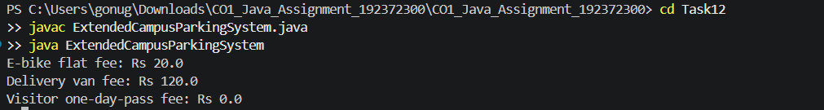

13. Conclusion
The Campus Smart Parking Management System demonstrates the practical application of Java programming and core object-oriented programming concepts. The system separates vehicle identification, parking slot management, ticket generation and fee calculation into different classes, making the program easier to understand and maintain. Arrays are used to represent the parking layout, while encapsulation helps protect data and organize class responsibilities.The implementation demonstrates important OOP concepts such as inheritance, method overriding, polymorphism, abstraction and interfaces. These concepts allow different vehicle categories to share common functionality while supporting their own specific behaviours and parking fee rules. The Day-4 extension further demonstrates how the existing design can be enhanced to support additional vehicle categories, special pricing conditions and an expanded parking structure.Overall, this assignment helped strengthen practical knowledge of Java programming, class design and object-oriented problem-solving. The final implementation and its functionality are supported by the student's VS Code execution results and screenshots.

14. References
- 1. Herbert Schildt, Java: The Complete Reference, 12th Edition, McGraw Hill, 2021.
- 2. Paul Deitel and Harvey Deitel, Java: How to Program, 11th Edition, Pearson, 2018.
- 3. Oracle, “The Java Tutorials – Object-Oriented Programming Concepts.”
https://docs.oracle.com/javase/tutorial/java/concepts/
- 4. Oracle, “Java Platform, Standard Edition Documentation.”
https://docs.oracle.com/en/java/javase/
- 5. Oracle, “The Java Collections Framework.”
https://docs.oracle.com/javase/8/docs/technotes/guides/collections/
- 6. Oracle, “Date and Time API – java.time Package.”
https://docs.oracle.com/javase/8/docs/api/java/time/package-summary.html
- 7. Object Management Group (OMG), OMG Unified Modeling Language (UML), Version 2.5.1, 2017.
https://www.omg.org/spec/UML/2.5.1/
- 8. Umbrello UML Modeller, “Umbrello UML Modeller Documentation.”
https://docs.kde.org/

